**Classification - Assignment**

Problem Statement or Requirement:

A requirement from the Hospital, Management asked us to create a predictive

model which will predict the Chronic Kidney Disease (CKD) based on the several parameters. The Client has provided the dataset of the same.

1. Identify your problem statement.
   1. Supervised Learning(Since the requirement, Input&Output were very clear)
   2. Classification Algorithm (Because the output seems to be categorical)
2. Tell basic info about the dataset (Total number of rows, columns)
   1. Total Number of Rows – 399
   2. Total Number of Columns – 25 (it may extend, if get dummies enabled)

3.) Mention the pre-processing method if you’re doing any (like converting

string to number – nominal data/Ordinal Data)

Preprocessing of data set is required, since the input were Ordinal data. So conversion is required using Label encoding

4.) Develop a good model with good evaluation metric. You can use any

machine learning algorithm; you can create many models. Finally, you

have to come up with final model

5.) All the research values of each algorithm should be documented. (You

can make tabulation or screenshot of the results.)

Developing a good model with confusion_Matrix and roc_auc_score.

Here, will starts with SVM Algorithm and followed by Decision tree and Random Forest with GridSearch Method.

SVM Algorithm :

Decision tree Algorithm:

Random Forest Algorithm :

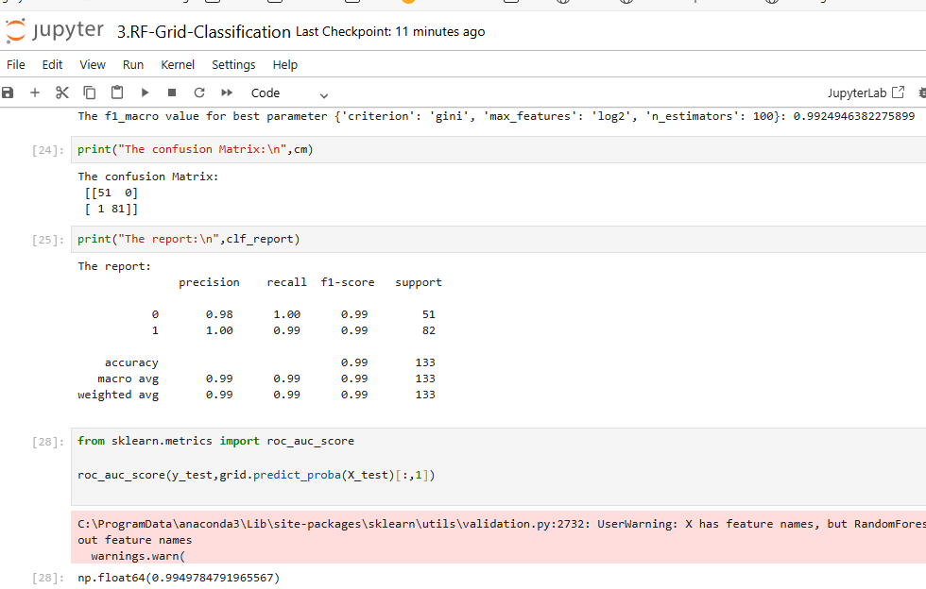

6.) Mention your final model, justify why u have chosen the same.

Our Final Model is SVM., using svm classifier model we achieved 100% means (1.0)

This model learned very well based on our Train and Test dataset. So, we are choosing this is the best model in this assignment.